

**ADDIS ABABA SCIENCE AND TECHNOLOGY UNIVERSITY**

**DEPARTMENT OF SOFTWARE ENGINEERING**

**DATA COMMUNICATION AND NETWORKS**

Group members

1. Erimias Tiruneh……………………………..ETS 051/12
2. Erimias Siraye………………………………..ETS0253/12
3. Estifnaos Gashawtena…………………..ETS0260/12
4. Eyuel Ketema……………………………….ETS0280/12
5. Mintesinot Markos……………………….ETS 1025/12

SUBMISSION TO TEACHER YONAS H.

SUBMISSION DATE: 16/8/2021

1. Describe the following digital signal encoding formats (which format is used by ethernet?)

* **Non return to zero:** NRZ Codes has 1 for High voltage level and 0 for Low voltage level. The main behavior of NRZ codes is that the voltage level remains constant during bit interval.
* The end or start of a bit will not be indicated and it will maintain the same voltage state, if the value of the previous bit and the value of the present bit are same.

1. **NRZ - L NRZ–LEVEL**

* 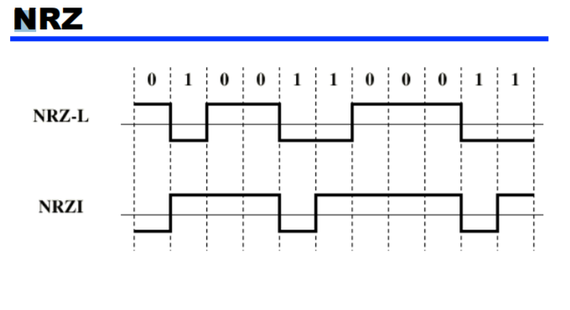There is a change in the polarity of the signal, only when the incoming signal changes from 1 to 0 or from 0 to 1. It is the same as NRZ, however, the first bit of the input signal should have a change of polarity.

1. **NRZ - I NRZ–INVERTED**

* If a 1 occurs at the incoming signal, then there occurs a transition at the beginning of the bit interval. For a 0 at the incoming signal, there is no transition at the beginning of the bit interval.
* NRZ codes has a disadvantage that the synchronization of the transmitter clock with the receiver clock gets completely disturbed, when there is a string of 1s and 0s. Hence, a separate clock line needs to be provided.

**NRZ pros and cons**

• Pros

* + Easy to engineer
  + Make good use of bandwidth

• Cons

* dc component
* Lack of synchronization capability

• Used for magnetic recording

• Not often used for signal transmission

1. Bi polar AMI (Alternate Mark Inversion) is a [synchronous](https://erg.abdn.ac.uk/users/gorry/course/phy-pages/sync.html) clock encoding technique that uses bipolar pulses to represent logical 1. The next logic 1 is represented by a pulse of the opposite polarity. Hence a sequence of logical 1’s are represented by a sequence of pulses of alternating polarity. The alternating coding prevents the build-up of a d.c. voltage level down the cable.

AMI (Alternate Mark Inversion) encoding was used extensively in first generation pulse code modulation networks, but suffers the drawback that a long run of 0's produces no transitions in the data stream (and therefore does not contain sufficient transitions to guarantee lock of a [DPLL](https://erg.abdn.ac.uk/users/gorry/course/phy-pages/dpll.html)). Successful clock recovery therefore relies on the user not wishing to send long runs of 0's and this type of encoding is not therefore transparent to the sequence of bits being sent. A modified AMI code periodically inserts additional pulses of the same polarity as the last logical 1.

These deliberate "violations" can be used to increase the clock content of the signal and help synchronization of a remote receiver's DPLL.

* “0” represented by no line signal
* “1” represented by positive or negative pulse
* “1” pulses alternate in polarity
* No loss of sync if a long string of “1” s (“0” still a problem)
* No net dc component
* Lower bandwidth
* Easy error detection

4. Pseudoternary – Bit 1 is encoded as a zero voltage and the bit 0 is encoded as alternating positive and negative voltages i.e., opposite of AMI scheme. Example: Data = 010010• “1” represented by absence of line signal

• “0” represented by alternating positive and negative

• No advantage or disadvantage over bipolar-AMI  
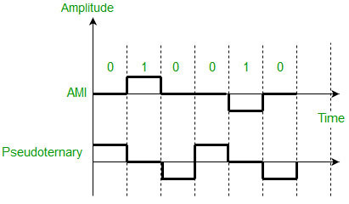

5. **Bi-phase Encoding**

The signal level is checked twice for every bit time, both initially and in the middle. Hence, the clock rate is double the data transfer rate and thus the modulation rate is also doubled. The clock is taken from the signal itself. The bandwidth required for this coding is greater.

There are two types of Bi-phase Encoding.

* Bi-phase Manchester
* Differential Manchester

**Manchester**

In this type of coding, the transition is done at the middle of the bit-interval. The transition for the resultant pulse is from High to Low in the middle of the interval, for the input bit 1. While the transition is from Low to High for the input bit **0**.

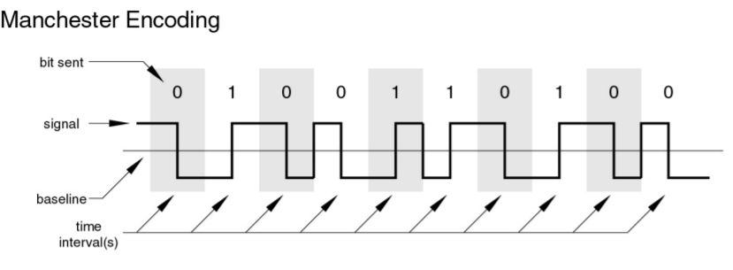

**Differential Manchester**

In this type of coding, there always occurs a transition in the middle of the bit interval. If there occurs a transition at the beginning of the bit interval, then the input bit is **0**. If no transition occurs at the beginning of the bit interval, then the input bit is **1**.

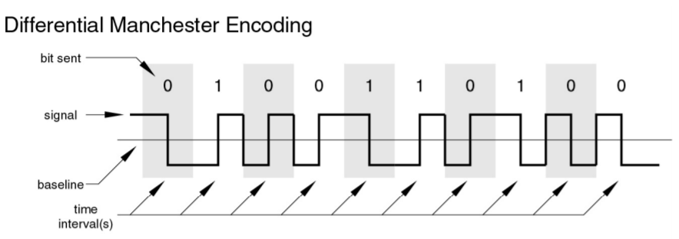

Bi-phase encoding Pros and Cons

• Pros

—Synchronization on mid bit transition (self-clocking)

—No dc component

—Error detection

• Con

—At least one transition per bit time and possibly two

—Maximum modulation rate is twice NRZ

—Requires more bandwidth

• Absence of expected transition